Nylon Rope Trick: *Synthesis of unsupported membranes of Nylon 6,10:*

Recipe: (These solutions have already been prepared for you)

|  |  |
| --- | --- |
| Organic Phase | Aqueous Phase |
| 3.0 ml SC  + 50 ml DCM | 4.40 g HMDA  +50 ml water  +4 g Na2CO3 |

1. Pour 50 ml of the organic phase to a 250 ml beaker in the hood. Then, with the beaker tilted at an angle, slowly pour 50 ml of aqueous solution down the side of the glass wall so that it will be sitting on top of the organic phase. Carefully tilt the beaker back to an upright position.
2. "Catch" the membrane that has formed at the interface with a chopstick. Draw it up and out, and attach the top end to another chopstick. Keep rotating the chopstick as you pull the fiber out and withdraw the Nylon fiber from the interface, spinning it onto the shopsticks.
3. Unwind the collapsed membrane into a large (1 to 2 liter) vessel of water to rinse away any soluble components (salts, mainly).
4. Separate the membrane into 1-2-foot-long portions.

*Tensile test properties of the collapsed film and other nylon fibers:*

1. Using the calipers, estimate the thickness of the wet fiber (D). Then measure the length of the Nylon fiber with a ruler.
2. Have one end of the wet rope held by your lab partner, and attach the other end to the force gauge. Pull the rope taught, but don’t pull hard yet. Measure the length of the wet film (L) and record the corresponding force (F) in your notebook, as well as the length. Keep extending the wet rope by having one of the members step back slightly until it breaks, and try to get at least 6 measurements. Repeat this procedure for at least two wet ropes produced from each recipe to establish how closely the data agree.

*Calculations:*

$$Draw ratio, λ = \frac{L}{L_{0}}$$

$$Engineering Strain ε = \frac{L-L_{0}}{L_{0}}$$

$$Engineering Stress σ=\frac{F}{A_{0}}$$

# **𝞂:** Calculated for each length/ force pair you got, the Force (in Newtons) is the force from the gauge. Your A₀ is the same for all; A₀ = (π*(D/2) $^2$)

**ε:** Calculated for each length/ force pair you got, L is each new length the rope was stretch to , L₀ is the original starting length of the rope.

Now for each force/ length pair, you should have a stress and strain data calculation. Plot these on a graph, like the one below. The stress-strain plot gives properties of the material like the elastic modulus and the yield stress which are independent of the shape and size of the test sample but depends on the rate of strain (or elongation rate). The elastic modulus is the slope of the stress-strain plot at very low strains.

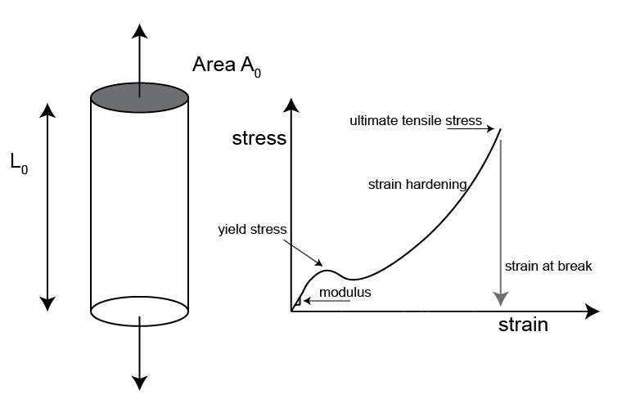

Figure: Schematic illustrating the tensile test and features on a stress-strain plot.